**Optimizing Sales Performance of an E-Commerce Company**

**A Proposal report for the BDM capstone Project**

Submitted by

Name: Lalit Kumar

Roll number: 21f3003123



IITM Online BS Degree Program,

Indian Institute of Technology, Madras, Chennai

Tamil Nadu, India, 600036

**Contents**

1 Executive Summary and Title 2

2 Organisation Background 2

3 Problem Statement 3

3.1 Problem statement 1 3

3.2 Problem statement 2 3

3.3 Problem statement 3 3

4 Background of the Problem 3

5 Problem Solving Approach 3

6 Expected Timeline 4

7 Expected Outcome 5

**Declaration Statement**

I am working on a Project titled “**Optimizing Sales Performance of an E-Commerce Company**”. I extend my appreciation to the various public and private organizations that have made their data publicly accessible, enabling me to conduct my research.

I hereby assert that the data presented and analyzed in this project report is genuine and accurate to the best of my knowledge and ability. The data has been sourced from publicly available secondary sources and has been carefully examined to ensure its reliability within the limitations of publicly accessible information.

Additionally, I affirm that all procedures employed for the purpose of data collection and analysis have been duly explained in this report. The outcomes and inferences derived from the data are an accurate depiction of the findings acquired through thorough analytical procedures.

I am dedicated to adhering to the principles of academic honesty and integrity, and I am receptive to any additional examination or validation of the data contained in this project report.

I understand that the execution of this project is intended for individual completion and is not to be undertaken collectively. I thus affirm that I am not engaged in any form of collaboration with other individuals, and that all the work undertaken has been solely conducted by me. In the event that plagiarism is detected in the report at any stage of the project's completion, I am fully aware and prepared to accept disciplinary measures imposed by the relevant authority.

I understand that all recommendations made in this project report are within the context of the academic project taken up towards course fulfillment in the BS Degree Program offered by IIT Madras. The institution does not endorse any of the claims or comments.



Signature of Candidate: (**Digital Signature**)

Name: Lalit Kumar

Date: 10 Sep 2024

# Executive Summary and Title

The organization is an Indian retail business specializing in a diverse range of products across multiple categories, with a strong online presence and a growing customer base.

Despite its market position, the company faces challenges in consistently meeting sales targets across various product categories. Some categories underperform, impacting overall revenue and profitability.

To address these challenges, this project will employ a data-driven approach to analyse sales performance, compare actual sales with targets, and understand customer behaviour. The goal is to identify areas of improvement, optimize sales strategies, and ensure alignment with organizational revenue goals. The expected outcome includes actionable insights that will help the company achieve its sales targets and sustain long-term growth.

# Organization Background

The organization is a retail business that specializes in a diverse range of products across multiple categories. The company has a robust online presence and a growing customer base that spans various demographics. With a commitment to providing high-quality products and excellent customer service, the organization has established itself as a leader in the retail sector.

However, the business faces challenges in meeting its sales targets consistently across all product categories. As the company expands its product lines and customer outreach, there is an increasing need to analyse sales performance, understand customer preferences, and optimize inventory management. This project is initiated to address these challenges by leveraging data-driven insights to enhance sales strategies and ensure that the organization meets its revenue goals.

**Data Source**: <https://www.kaggle.com/datasets/benroshan/ecommerce-data/data>

# Problem Statement

## **Problem statement 1:** To identify underperforming product categories and subcategories to implement targeted sales improvement strategies.

## **Problem statement 2:** There is a need to compare actual sales performance against set targets to understand the shortfall and areas for improvement.

## **Problem statement 3:** To analyze customer purchase behavior to optimize product offerings and enhance sales.

# Background of the Problem

As the organization expands, it faces increasing pressure to meet ambitious sales targets set for various product categories. Despite having a strong market presence and a loyal customer base, the company has observed inconsistencies in sales performance. Some product categories consistently meet or exceed targets, while others fall short, impacting overall revenue.

This issue stems from a lack of detailed analysis of sales data and customer behaviour. Without a clear understanding of which products are underperforming and why, the company struggles to allocate resources effectively and implement targeted marketing strategies. Moreover, the absence of a systematic approach to compare actual sales against targets makes it difficult to identify gaps and take corrective actions.

The organization recognizes the need for a data-driven approach to analyse sales trends, customer preferences, and product performance. By addressing these issues, the company aims to optimize its sales strategies, improve profitability, and ensure that all product categories contribute effectively to the overall revenue.

# Problem Solving Approach

To address the identified problems, a comprehensive data analysis approach will be adopted. The project will involve the following key steps:

**1. Data Collection, Cleaning and Preparation:**  
The first step involves gathering the three datasets from the given source i.e. List of Orders, Order Details, and Sales Targets. The data will be cleaned, organized, and prepared for analysis. This includes handling missing values, ensuring data consistency, and merging the datasets based on common identifiers like Order ID and Product Category.

**2. Sales Performance Analysis:**  
A detailed analysis of sales performance across different product categories and subcategories will be conducted. This involves calculating key metrics such as total sales, profit margins, and sales growth over time. The analysis will help identify which categories are underperforming and which are exceeding expectations.

**3. Target vs. Actual Performance Comparison:**  
The project will compare actual sales data against the set sales targets for each product category. This comparison will highlight areas where sales targets are not being met and quantify the shortfall. The analysis will also explore the reasons behind these gaps, such as seasonality, market trends, or customer preferences.

**4. Customer Behaviour Analysis:**  
Understanding customer behaviour is crucial for optimizing product offerings. The project will analyse customer purchase patterns, including frequency of purchases, average order value, and preferred product categories. By understanding customer preferences, we can optimize marketing efforts and drive sales.

**5. Recommendations and Strategy Development:**  
Based on the findings from the analysis, the project will develop recommendations to improve sales performance. These may include strategies such as re-pricing underperforming products, optimizing inventory levels, targeted marketing campaigns, and improving customer engagement.

**6. Reporting and Visualization:**  
The final step involves creating detailed reports and visualizations to present the findings and recommendations. These reports will be used by management to make informed decisions and track the implementation of the recommended strategies.

# Expected Timeline

## Work Breakdown Structure:

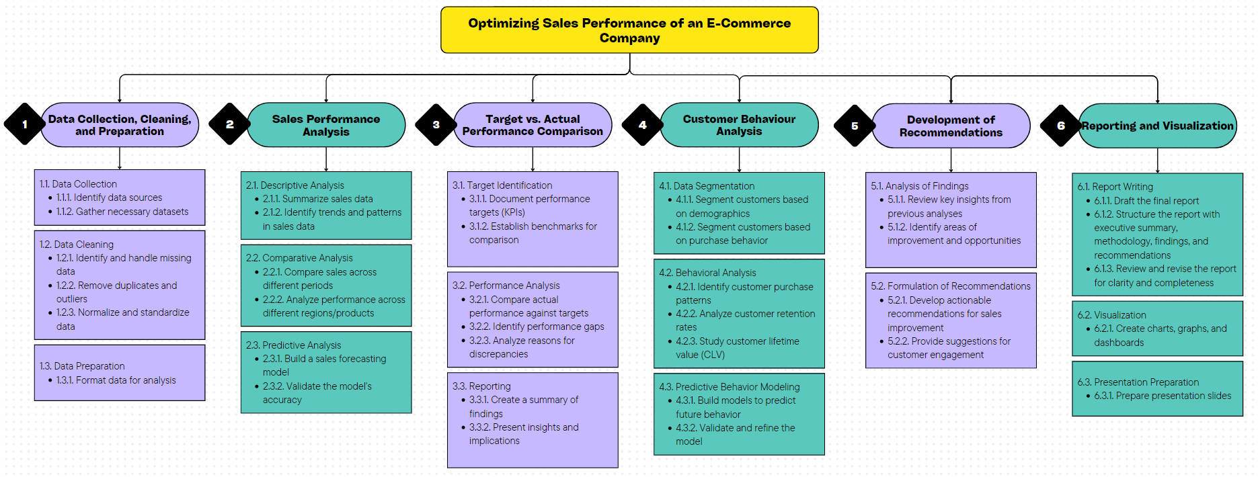

Figure 1 Work Breakdown Structure

## Gantt chart

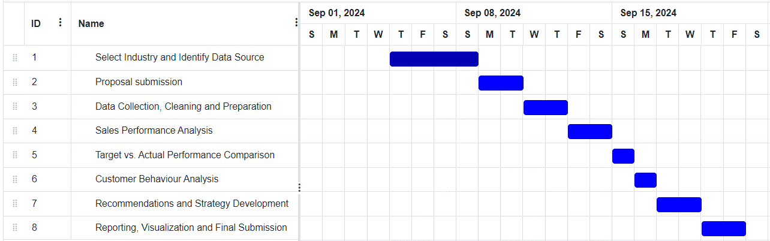

*Figure 2 Expected timeline for completion of project (Gantt chart).*

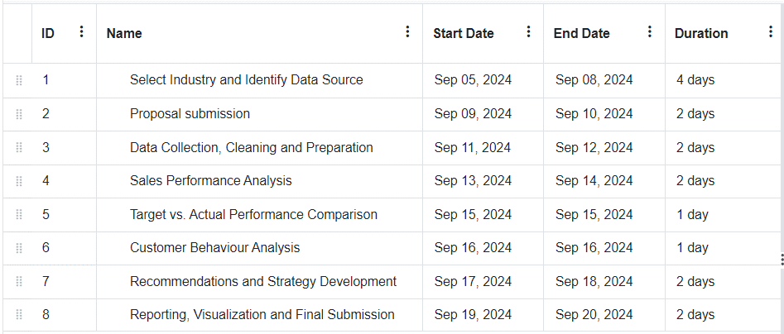

*Figure 3 Expected timeline for completion of project (Table).*

# Expected Outcome

By the end of the project, the organization will have a clear understanding of its sales performance across different product categories. The project is expected to result in improved alignment between actual sales and targets, optimized inventory, increased profitability, and enhanced decision-making capabilities. The recommendations provided will serve as a roadmap for the organization to achieve its sales goals and sustain long-term growth.